Please share any title ideas below:
Ocean acidification leads to physiological trade-offs in the Pacific oyster, Crassostrea gigas

ETS, Liam, Wilber, Brook Nunn, Gary Dickinson, Steven Roberts

ABSTRACT

INTRODUCTION

The global decrease in oceanic pH, ocean acidification, continues unchecked even as we become increasingly aware of its detrimental effects on a variety of aquatic taxa. Current measurements have already recorded decreases in surface ocean pH which are in accordance with modeled predictions of a pH drop by at least 0.3 units by the year 2100 (Orr et al. 2005; Caldeira & Wickett 2005; Feely et al. 2010; Feely et al. 2012; Gruber et al. 2012; Friedrich et al. 2012). The coastal ocean, home to productive fisheries and diverse ecosystems, may see even greater changes in pH due to the plethora of effects caused by close proximity to human influences on the environment (i.e. deforestation, agriculture, mining, increasing population sizes) (reviewed in Duarte et al. 2013; Bolla et al. 2007). Increased understanding of nearshore species’ responses to ocean acidification and other stressors could help mitigate the effects on some of these ecologically and economically important organisms by providing relevant information in management decisions. Development of accurate biomarker tools is needed to understand the scope of the effects that ocean acidification will have on nearshore biota, as well as the physiological plasticity that is available to species as they face environmental change. Pacific oysters, Crassostrea gigas, are both economically and ecologically important in the nearshore environment worldwide. They provide a range of ecosystem services (Coen and Luckenbach 2000) as well as being one of the most harvested molluscan aquaculture species, a group which makes up 75.5% (13.9 million tonnes) of marine aquaculture (FAO 2012).

C. gigas is an estuarine species that inhabits areas prone to episodes of low pH/high pCO2 water along with other environmental fluctuations. Given that they occupy a variable environment and are broadcast spawners, a life history characteristic that potentially produces large amounts of genetic variability each generation, C. gigas may already have the plasticity and the evolutionary capability to acclimatize or adapt to an ocean with lower pH (Zhang et al. 2012). The Pacific oyster provides an efficient model for a molecular exploration due to its published genome sequence (Zhang et al. 2012) and previous work that has done much to increase our understanding of its (and its congener’s) responses on a more macro-scale (e.g. Lannig et al. 2010; Matoo et al. 2013; Gazeau et al. 2007; Parker et al. 2010). Despite the potential ability to acclimatize or adapt, many studies to date have demonstrated acute and chronic negative effects of ocean acidification on C. gigas at both larval and adult stages. C. gigas larvae experience developmental delay and shell malformations in response to low pH (Timmins-Schiffman et al. 2012; Barton et al. 2012; Kurihara et al. 2007; Parker et al. 2010; Gazeau et al. 2011). Adult C. gigas are also affected negatively by ocean acidification in terms of fertilization (Parker et al. 2010), calcification (Gazeau et al. 2007), and ability to respond to a secondary stressor (Lannig et al. 2010).

Many previous studies on the invertebrate response to ocean acidification have focused on calcification and shell properties (e.g. Beniash et al. 2010; Michaelidis et al. 2005; Welladsen et al. 2010; Gazeau et al. 2007). The reason for the significant impacts of ocean acidification on calcium carbonate structures is likely linked to shifts in energy budget as species deal with the stresses of acid-base balance and altered hydrochemistry (e.g. Stumpp et al. 2011a). The inclusion of metrics that measure shifts in energy budget, such as fatty acid profiles and proteomic responses, can provide greater insight into the mechanisms behind the ocean acidification response, especially when combined with functional assessments of shell properties.

Proteomics and other broad-scale molecular tools provide efficient means to assess physiological processes at the molecular level. A particularly useful approach is shotgun proteomics, which quantifies expression of all proteins in a tissue, rendering an unbiased portrait of cellular physiology without the bias of applying pre-conceived molecular assays. Shotgun proteomics is an alternative to 2-dimensional electrophoresis isolation followed by mass spectrometry, which provides more information on protein mass and charge, but is limited in the number of proteins that can be identified. The advantages of the shotgun technique are: 1) novel responses to stressors can be discovered and 2) protein-protein interactions can be clarified. Especially when applied with other assays of physiological response, proteomics can elucidate the integrated organism response. Proteomics have been applied across species of oysters to explore various environmental effects (Thompson et al. 2012a and 2012b; Thompson et al. 2011; Simonian et al. 2009; Liu & Wang 2012) including response to ocean acidification (Dineshram et al. 2013; Parker et al. 2011; Tomanek et al. 2011), tissue-specific protein profiles (Corporeau et al. 2012; Oliveira et al. 2012; Timmins-Schiffman et al. 2013), and developmental processes (Huan et al. 2012).

We investigated the response of C. gigas to ocean acidification within the context of physiological trade-offs. Oysters were exposed to three different levels of pCO2 for one month and a subset were then exposed to an additional mechanical stress or heat stress. Potential physiological trade-offs were assessed by measuring the effects of elevated pCO2 on shell micromechanical properties, fatty acid profiles, response to a second stress, and proteomics. Shell properties and fatty acid profiles provide insight into two important physiological processes, calcification and lipid metabolism, respectively. Global environmental change will encompass more changes than ocean acidification, therefore a second stressor can clarify the potential interactive effects of multiple changes in the environment on an organism. A characterization of the proteomic underpinnings behind responses to ocean acidification will demonstrate the interactions between physiological processes involved in the stress response, as well as solidify our understanding of the mechanisms behind the effects of ocean acidification.

METHOD

Ocean acidification system
This experiment was conducted at the Friday Harbor Labs Ocean Acidification Environmental Laboratory, Friday Harbor, Washington, USA where oysters were exposed to pCO2 values of 400 uatm, 1000 uatm, and 2800 uatm. The system and control of water chemistry has been previously described in detail (Timmins-Schiffman et al. 2012; O’Donnell et al. 2013). Briefly, incoming water was filtered (0.2 µm) and stripped of CO2. As the water flowed into the different treatment tanks, CO2-free air and CO2 were added back to reach set points that were continuously monitored by a DuraFET III pH probe (Honeywell, Morristown, NJ, USA). From the treatment tanks, water flow into the eight replicate chambers for each of the three treatment level was 57.5 mL/min. For this experiment, set points were calculated for 13°C and estimated total alkalinity (AT) of 2100 µmol/kg for pCO2 values of 400 uatm (pH 8.03), 1000 uatm (pH 7.67), and 2800 uatm (pH 7.24).

Experimental Design
Adult oysters (average shell length +/- SD = 51+/- 5 mm, average width = 38 +/- 6 mm) collected from Oyster Bay, Washington were maintained in 3.5-L chambers (n = 6 oysters per container) and acclimated for two weeks (T = 13°C, pH = 8). Oysters were fed 120,000 cells per mL per day of Shellfish Diet 1800 (Reed Mariculture, Campbell, CA, USA). Containers were cleaned every other day with freshwater to prevent fouling. At the beginning and end of the experiment, buoyant weight was taken. Relative growth rate of oyster cohorts within each treatment were calculated for buoyant weight based on Hoffmann and Poorter (2002). For each treatment, the difference in means of natural log-transformed data was divided by 29 days. Analysis of variance was used to determine the main effects and interactions of time and pCO2 on buoyant weight, using the model:
bw~t*pCO2
where bw is the measured buoyant weight for an oyster, t is time point (either start or end of the experiment) and pCO2 is the treatment condition. Analyses were performed in R (R Core Team 2012).
Oysters were held in one of three treatments for 29 days. At the end of the treatment period oysters were either immediately sampled (n =16), subjected to mechanical stress by centrifugation (5min, ~100rpm) and sampled (n = 8), or subjected heat shock for one hour (n = 24). Centrifugation has previously been shown to stimulate a stress response in oysters as evidenced by increased circulating noradrenaline and impacts on hemocyte function (Lacoste et al. 2001; Lacoste et al. 2002).
Heat shock occurred at three different temperatures - two sublethal (42° and 43°C) and one lethal (44°C) - for three different groups of oysters from each of the pCO2 treatments of 400, 1000, and 2800 µatm. The lethal heat shock temperature was previously determined for this group of oysters and is defined as the temperature at which 100% mortality occurs within one week after a one hour exposure (Clegg et al. 1998). The heat shock occurred in 800 mL of sea water equilibrated to the correct temperature in a circulating water bath. Since oysters considerably decrease the temperature of the bath when, we added a pre-heating step of 10 minutes in one beaker after which the oysters were transferred into another beaker for the full hour. After heat shock, oysters were returned to the flow through system at pH = 8.03 and 13°C. Mortality was the only parameter assessed for the temperature treatment.
After 29 days, a section of the posterior gill lamellae was dissected and immediately flash frozen in liquid nitrogen for protein expression analysis. Only samples held at 400 uatm and 2800 uatm, both mechanically stressed and without additional stress, were considered for protein analysis. Remaining viscera from all oysters were put in a separate tube and flash frozen for fatty acid analysis. Both shell valves were gently cleaned of remaining tissue and left to air dry for characterization of shell strength and structure.

Seawater Chemistry Analysis
Spectrophotometric (spec) pH was measured for all treatments 19 out of the 29 days of the experiment as described in SOP 6b by Dickson et al. (2007). On days 5, 7, 11, 14, 20, 24, and 26 spec pH was used to measure the pH of the water inside two of the eight experimental chambers per treatment to ensure consistency with set points. Salinity was recorded with a conductivity meter (Hach sensION5, Loveland, CO, USA) and treatment temperature was verified with a Fluke 1523 thermometer (Fluke, Everett, WA, USA) whenever spec pH was measured. AT was measured using an open cell titration as described in SOP 3b (Dickson et al. 2007) for the treatment reservoir water and for two chambers on days 5, 11, 20, and 26. If the AT titration was not done on the day of collection, the water sample was poisoned with mercuric chloride and stored in a sealed borosilicate glass jar. CO2SYS (Robbins et al. 2010) was used to calculate calcium carbonate saturation state of aragonite and calcite, carbonate ion concentration, and pCO2 with AT and pH as inputs and using the following constants: Lueker et al. (2000) for CO2 constants; Dickson (1990) for KHSO4; total scale (mol/kg SW) for pH scale; and Wanninkhof (1992) for air-sea flux.

Liquid chromatography and tandem mass spectrometry (LC-MS/MS)
Protein extraction and desalting were performed on gill tissue from four mechanically stressed and four unstressed oysters held in the present day and the highest treatment level, 400 and 2800 uatm, respectively (n = 16 oysters total) as described in Timmins-Schiffman et al. (2013). Each of the 16 protein samples was injected three times, with injections occurring in a randomized order. LC-MS/MS and data acquisition were carried out as previously described (Timmins-Schiffman et al. 2013).

Protein Informatics Analysis
Peptide tandem mass spectra were correlated to in silico-generated tandem mass specra resulting from the Pacific oyster proteome (Fang et al. 2012) using SEQUEST (Eng et al. 1994). SEQUEST identifies amino acid sequences in a protein database using molecular weight and then uses predicted fragmentation patterns of ions in the database to match tandem mass spectrometry data. Using PeptideProphet from the trans-proteomic pipeline (TPP), peptides were assigned a relative score for best match to the database (Eng et al. 1994; Eng et al. 2008). Only peptides with a PeptideProphet probability score of at least 0.9 were considered for further analysis. Additionally, a protein was considered for analysis only if it had at least 8 spectral counts across all 48 injections (1 spectral count = 1 peptide matched to that protein). Within a biological replicate, a protein was considered to have a non-zero expression value if it had at least 2 unique peptide matches.
NSAF (normalized spectral abundance factor), a metric based on spectral counting (Florens et al. 2006), was used to quantify protein expression. Total spectral counts (SpC) for each oyster were averaged across the three technical replicates. NSAF was calculated by dividing average SpC for each protein by the protein length (L) and then dividing SpC/L by the sum of all SpC/L within a biological replicate. This workflow was executed in SQLshare and details can be found in Supplementary Information S2.
Differential protein expression between treatment groups (400 vs. 2800 µatm, 400 µatm vs. 400 + mechanical stress, and 2800 µatm vs. 2800 + mechanical stress) was determined using the qvalue package in R (Dabney et al.) with a q-value cut-off of 0.1. Use of a q-value instead of a p-value from a t-test allows for a multiple comparisons correction using the positive false discovery rate (Storey 2002; Storey and Tibshirani 2003). For all the significantly differentially expressed proteins (q-value < 0.10), if a protein was expressed in a treatment group all oysters in that group expressed that protein.
Oyster proteins (Fang et al. 2012) were annotated by comparing sequences to the UniProt-KB/SwissProt database (http://uniprot.org) using the blastp algorithm (Altschul et al. 1997) with an e-value limit of 1E-10. Based on homology with the SwissProt database, oyster proteins were further annotated with Gene Ontology (GO) and GO parent categories (GO Slim).
Fold change in protein expression between treatment groups was found by dividing the average NSAF across all four biological replicates in one treatment by the average NSAF of the other treatment. If a protein was not expressed, its expression value was considered 0 and was included in the average. Only proteins expressed in more than one oyster were included in this analysis. Proteins that had at least a 5-fold difference in expression between treatment groups and proteins expressed in only one treatment, regardless of q-value, were explored for enrichment of specific biological processes compared to the entire gill proteome using the Database for Annotation, Visualization, and Integrated Discovery (DAVID) v. 6.7 (Huang et al. 2009a, b http://david.abcc.ncifcrf.gov/). The background protein list was made from the entire sequenced gill proteome. The results were visualized in Revigo and plotted in R. Overlaps in the responses to different stressors were explored using a Venn diagram of the proteins that showed at least a 5-fold difference between treatments in eulerAPE v. 1.0 (http://www.eulerdiagrams.org/eulerAPE/).

Fatty Acid Analysis
Fatty acid analysis was carried out on unstressed oysters from the three pCO2 treatments (400, 1000, and 2800 µatm; n = 8 per treatment). All three pCO2 treatments were used to investigate if lipid metabolism differed between moderate and highly elevated pCO2. Whole body tissue (minus the dissected gill) was lyophilized overnight and tissues were homogenized with a pestle for use in fatty acid extractions (2.5 mg per extraction). Extractions were performed following the protocol described in Galloway et al. (2012) except two chloroform removals were carried out. Fatty acid methyl esters were identified by running the samples on a HP 6958 gas chromatograph with an auto-sampler and flame-ionization detector using an Agilent DB-23 column (30 m, 0.25 mm diameter, 0.15 µm film) (Supelco, Bellefonte, PA, USA). Peaks were identified based on comparison of retention times with known standards.

Shell Micromechanical Properties
Micromechanical testing was conducted on left shell valves of C. gigas that had been exposed to 400, 1000 or 2800 µatm to compare different calcite saturation states. All reagents, supplies and equipment for sample preparation were purchased from Allied High Tech Products, Inc. (Rancho Dominguez, CA, USA) unless otherwise stated. Micromechanical testing was conducted within the outermost 3 mm of the shell posterior, the region of the shell where growth occurs most rapidly. Although we could not definitively differentiate shell grown during the experimental exposure from pre-existing shell, observations of growth during the course of the experiment are consistent with a 3 mm deposition of new shell.
To prepare samples, shell valves were first cut across their width using a water-cooled diamond tile saw (Skilsaw, #3540), separating the anterior from the posterior portion of the shell. The posterior segment of valves (approximately 35 mm in length) was then cleaned using Micro Organic Soap and a cotton ball to remove oil and debris and mounted on a glass microscope slide using mounting wax. Slides with mounted shells were secured to the cutting arm of a low speed diamond saw (TechCut 4, cooled with proprietary cutting fluid ) and the shell segment was cut longitudinally, transecting the most posterior edge. Sectioned shell valves were removed from slides, cleaned again with Micro Organic Soap, dried on a hot plate at 70°C, and mounted in epoxy resin. Mounted samples were then ground and polished on a manual grinding/polishing machine (M-Prep 5) by passing samples through a grinding series of 180, 320, 600 and 800 grit and then polishing with a 1 µm diamond suspension and finally a 0.04 µm colloidal silica suspension. Samples were cleaned with Micro Organic soap and checked under a metallurgical microscope after each step of the grinding/polishing process, and were re-polished if necessary until the surface of each sample was completely even and free of scratches. No etching of shells was observed during grinding or polishing.
Vickers microhardness tests were conducted using a microindentation hardness tester (Clark Instrument MHT-1, SUN-TEC, Novi, MI, USA) on polished shells at 0.245 N load and 5 s dwelling time. Indents were made within the bulk, foliated layer of the shell. Seven to eight indentations were made per sample and each indent was placed at least 45 µm away from other indents and the sample’s edges. Vickers hardness numbers (VHN) were averaged for each shell sample. Following microhardness testing, each indent was photographed at 80x magnification on a metallurgical microscope (Jenco MET-233, Portland, OR, USA) equipped with a camera (Leica EC3, Buffalo Grove, IL, USA). Photographs were used to quantify the longest crack produced by each indent, which was measured using image analysis software (Leica LAS EZ, Ver. 3.0) as the radius of a circle radiating from the center of the indent enclosing all visible cracks (Supplementary Information S1). Hardness and crack radius measurements were used to calculate fracture toughness (K_{c}) for each sample as described elsewhere (Anstis et al., 1981; Baldassarri et al., 2008):

K_{C} = 0.0154 x (E/H)^{1/2} x (P/C^{1.5})

where 0.0154 is a calibration constant, E is an elastic modulus (empirically determined for C. gigas as 73 GPa: Lee et al. 2008), H is hardness in GPa, P is applied load in N and C is crack radius in μm.
Statistical analysis for micromechanical properties was conducted using SPSS (Ver. 19, IBM, Armonk, NY, USA). Outliers were calculated in SPSS as values greater than 1.5 times the interquartile range below or above the first or third quartile respectively, and were removed from the dataset (at most two per treatment group). Data were analyzed using one-way analysis of variance followed by post-hoc testing. Normality and equal variance was tested using a Kolmogorov–Smirnov test with Lilliefor’s correction and a Levene test, respectively. Fracture toughness data met both assumptions and a Tukey HSD post-hoc test was used. As hardness data was normally distributed but did not meet the equal variance assumption, a Welch ANOVA followed by Games-Howell post-hoc testing was applied.

RESULTS

Seawater Chemistry Analysis
The pCO2 levels for the three different treatments remained consistent throughout the one month experiment (Table 1). Average pH(±sd) for treatments as measured by the DuraFET probe were 8.02 ± 0.02, 7.63 ± 0.10, and 7.29 ± 0.10 for the 400, 1000, and 2800 µatm treatments, respectively. Spec pH corroborated the DuraFET measurements (spec pH data not shown). The pCO2 in containers with oysters was approximately 40 µatm higher than the source water pCO2, except for the 2800 µatm treatment where it was approximately 75 µatm lower than the source water. Total alkalinity was 9% higher in the chambers compared to the source water for 400 µatm, 13% higher at 1000 µatm, and 3% lower at 2800 µatm. Calcite was undersaturated (omega<1.0) only at the highest pCO2 level and aragonite was undersaturated at the two highest pCO2 levels (1000 uatm and 2800 uatm).

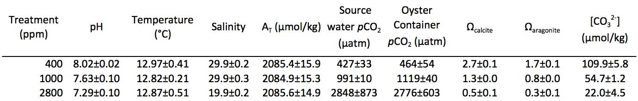
Table 1: Water chemistry summaries for all 3 treatments - Values are averages for the 29 days +/- standard deviation. Salinity is an average of 19 measurements and AT was measured four times. pH and temperature values are from the continuous monitoring by the DuraFET probe. pH, temperature, salinity, and AT were directly measured; all other parameters were calculated using CO2calc.

Oyster Growth
Relative growth rate (RGR) for shell mass exposed to increased pCO2, as measured by buoyant weight, was not statistically significant (Table 2). There was no significant effect of pCO2 on shell mass (p > 0.05). There was a significant effect of time on shell mass across all treatments (F = 4.399, p = 0.0371), indicating shell growth in all treatments.

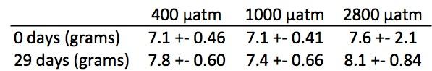
Table 2. Average buoyant weight +/- 95% confidence intervals

Heat Shock Response
There was no difference in mortality in response to heat shock (HS) across the three pCO2 treatment groups (Figure 1). One hundred percent mortality occurred across all three treatments by day 5 post-HS at the lethal temperature (44°C). There was no mortality by day 6 post-HS in the 42°C group (data not shown). In 400 and 2800 µatm pCO2 treatment groups there was 25% mortality by day 6 post-HS and 38% mortality in the 1000 µatm group.
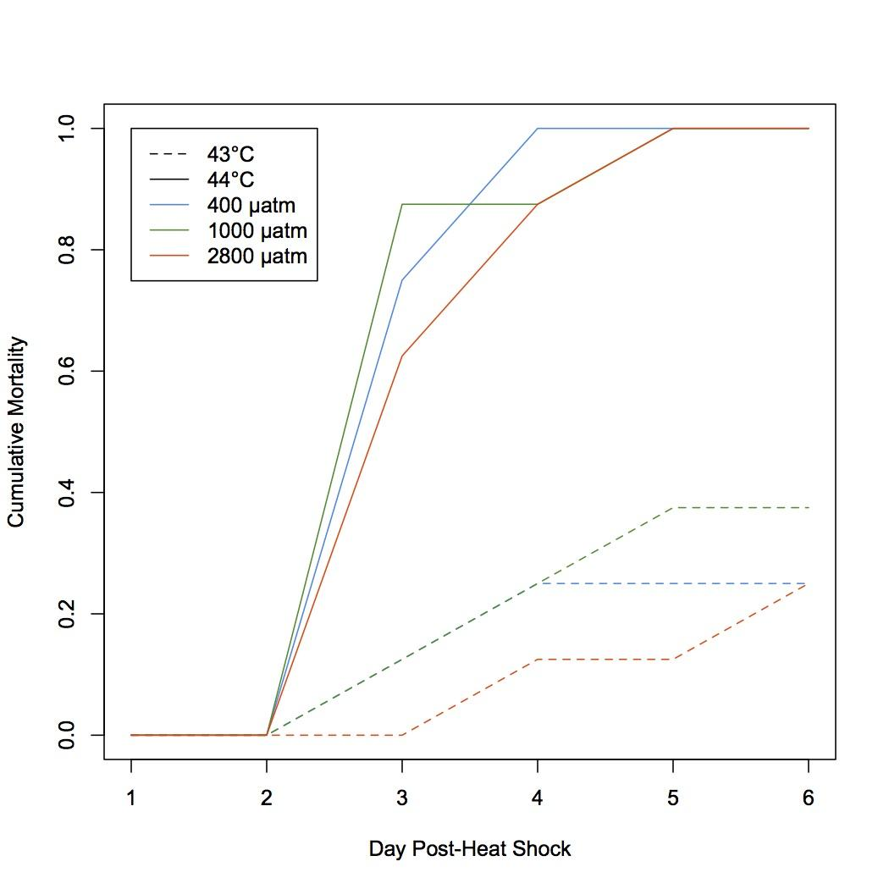
Figure 1. Oyster mortality after 1 hour heat shock at 43°C (dashed lines) or 44°C (solid lines). Mortality from heat shock did not differ between groups of oysters exposed to different pCO2 for 1 month - 400 µatm (blue), 1000 µatm (green), 2800 µatm (orange).

Protein Informatics Analysis
After filtering (see methods), 700,733 peptides were considered for analysis corresponding to 1,616 proteins (Supplementary Table S4, summary statistics in Table 3). Eighty-nine percent (1,449) of the proteins were annotated using the UniProt-KB/SwissProt database and 77% (1,250) were further annotated with Gene Ontology information (Supplementary Table S5).

Table 3. All proteins identified for each oyster across all 3 technical replicates (Total Proteins), number of proteins identified in each technical replicates, and proteins found in common among all 3 technical replicates for that particular oyster (row 5).

In comparing the proteomic response of oyster gill tissues under high pCO2 conditions, 64 proteins were identified as elevated (>/= 5-fold) under high pCO2 conditions whereas 55 proteins were expressed at decreased levels under high pCO2 conditions (Supplementary Table S4,Figures 2A and 3A). Gene enrichment analysis revealed enriched proteins are associated with cell junction organization / assembly (ie contactin) and morphogenesis (ie cadherin-23). (Supplementary Table S6). Two proteins were differentially expressed at 2800 µatm pCO2 compared to 400 µatm, calcium-regulated heat stable protein 1 (CGI_10021754) and thymidine phosphorylase (CGI_10027618), both expressed only in the oysters held under high pCO2 conditions (Table 5).

Ninety-nine proteins demonstrated at least 5-fold difference in expression between upon mechanical stress exposure at 400 µatm. Forty-seven were elevated under mechanical stress and 52 proteins were expressed at a lower level (Supplementary Table S4, Figures 2B and 3B). In response to mechanical stress at 400 µatm there a relative limited number enriched biological process identified (3) all with pvalues = 0.096 (Supplementary Table S6). Two proteins were differentially expressed that included nucleolar protein 56 (CGI_10027124) which was expressed only under mechanical stress conditions and adenylosuccinate lyase (CGI_10024111) which was expressed only in the absence of mechanical stress (Table 5).

Sixty-nine proteins were elevated (>/= 5 fold) when oysters held at 2800 µatm were subjected to mechanical stress, and at 52 proteins were expressed at decreased levels. (Supplementary Table S4, Figures 2C and 3C). A greater number of proteins contributed to a far greater number of enriched biological processes as determined through gene enrichment analysis. re enriched in the >5-fold protein set in response to mechanical stress at 2800 µatm, the most enriched beaing

neuromuscular process, cell-cell junction assembly, and tissue morphogenesis (Supplementary Table S6).

LikewiseNine proteins were differentially expressed in response to mechanical stress at at elevated pC02. Six of these proteins were expressed only in under mechanical stress conditions (NADH dehydrogenase (CGI_10010509), dynein heavy chain 3 (CGI_10010858), 40S ribosomal protein S11 (CIG_10024554), cytochrome c oxidase subunity 5B (CGI_10019936), glutathione S-transferase Mu 3 (CGI_10000124), and dual oxidase 2 (CGI_10025370)). Cytochrome b-c1 complex subunit 2 (CGI_1005784) was expressed at an elevated level (1.5-fold) under mechanical stress conditions. Integrin alpha-4 (CGI_10023513) was expressed at a lower level (2 fold) under mechanical stress conditions and thymidine phosphorylase (CGI_10027618) was not detected under mechanical stress conditions.

Table 4. Number of proteins up- or down-regulated for each stress situation. “Only control” and “only treatment” means that those proteins have an expression of 0 in the other treatment group. All proteins are included in totals, including those that are expressed in only one oyster for the particular comparison. Not included are proteins with an expression of 0 in both treatment groups compared.

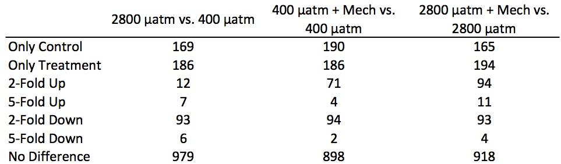

Figures 2A-C. Expression values (log(NSAF*10000)) for stress versus control treatment for 2800 µatm vs. 400 µatm (A), 400 vs. 400 µatm + mechanical stress (B), 2800 vs. 2800 µatm + mechanical stress (C). Green points are proteins that are expressed in only one treatment, pink points represent proteins that are at least 5-fold different between the treatment groups, blue points are proteins that are 2- to 5-fold different, and gray points are less than 2-fold different between groups.
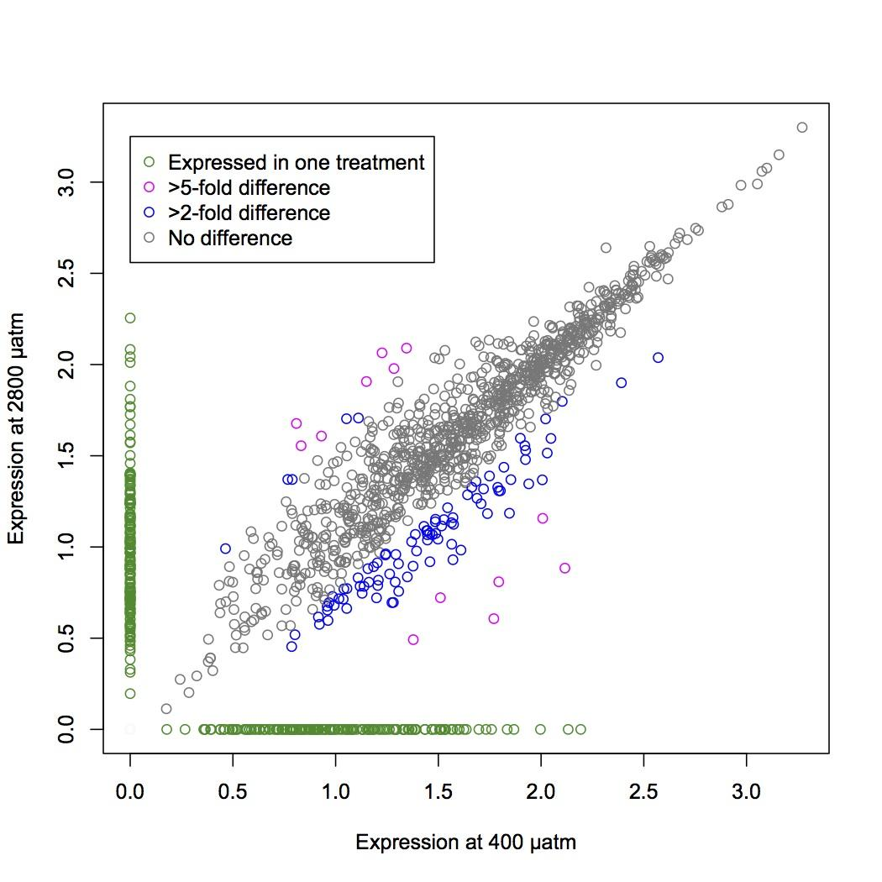

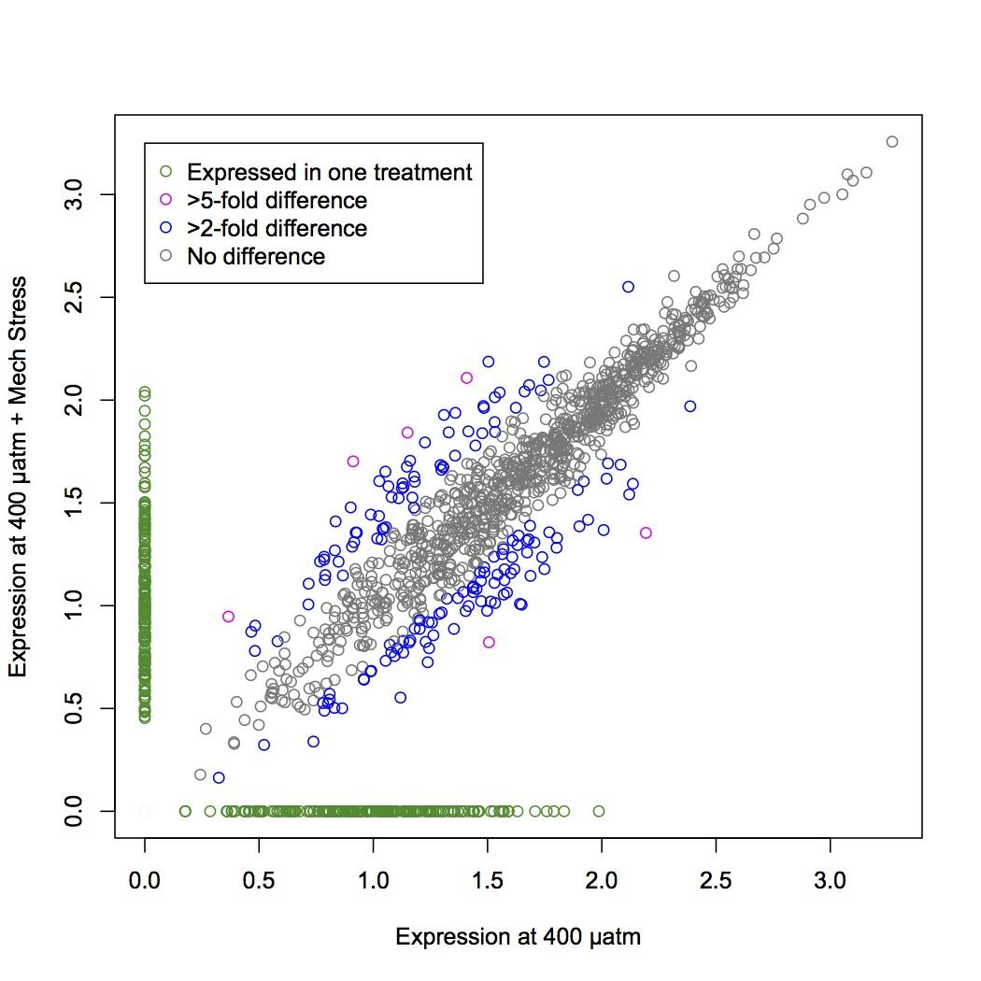
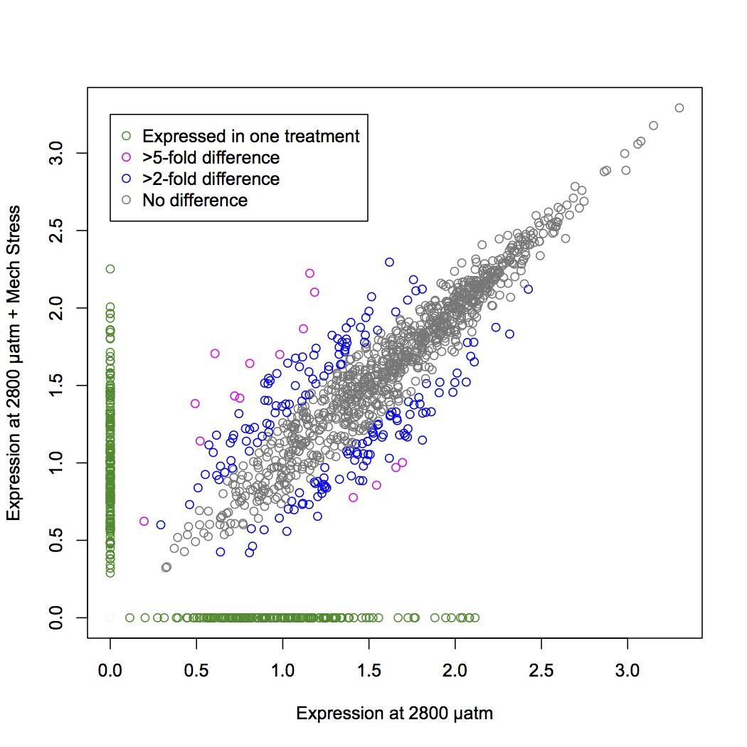
Figures 3A-C. Below are heat maps depicting log-transformed expression values (NSAF) for comparisons between treatments: 2800 µatm vs. 400 µatm (A), 400 vs. 400 µatm + mechanical stress (B), 2800 vs. 2800 µatm + mechanical stress (C). Proteins included in the heat maps were expressed in >1 oyster across the two treatments being compared.
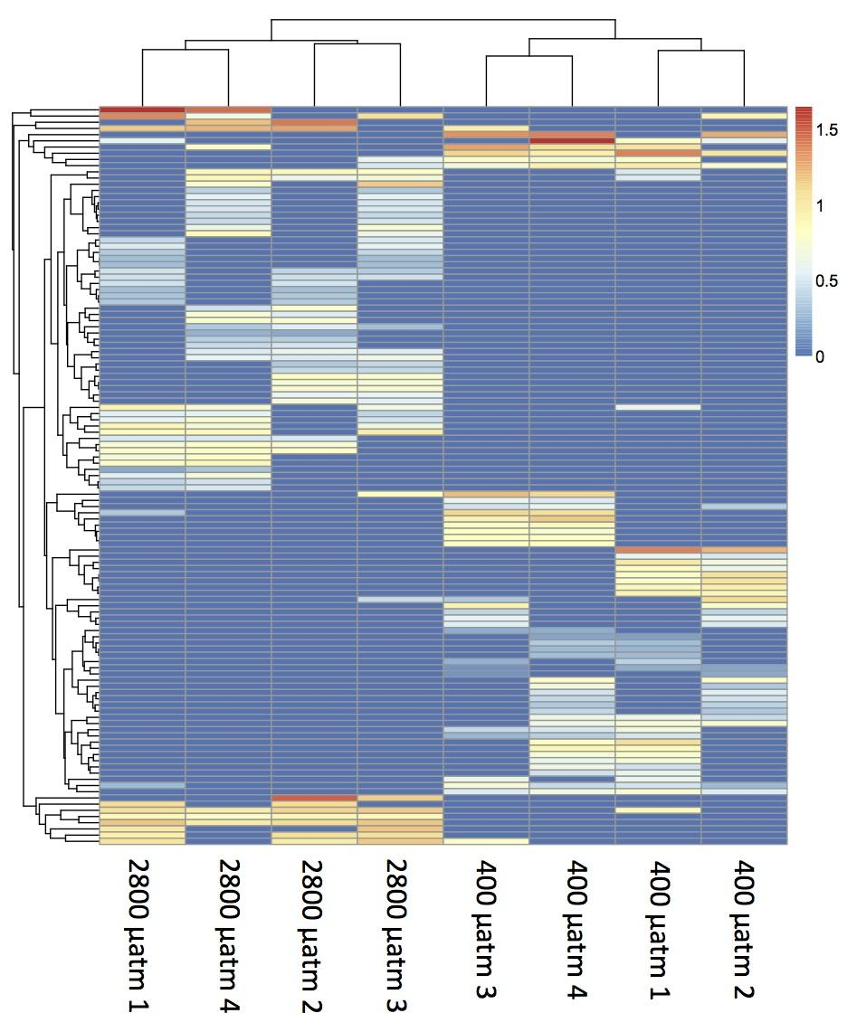
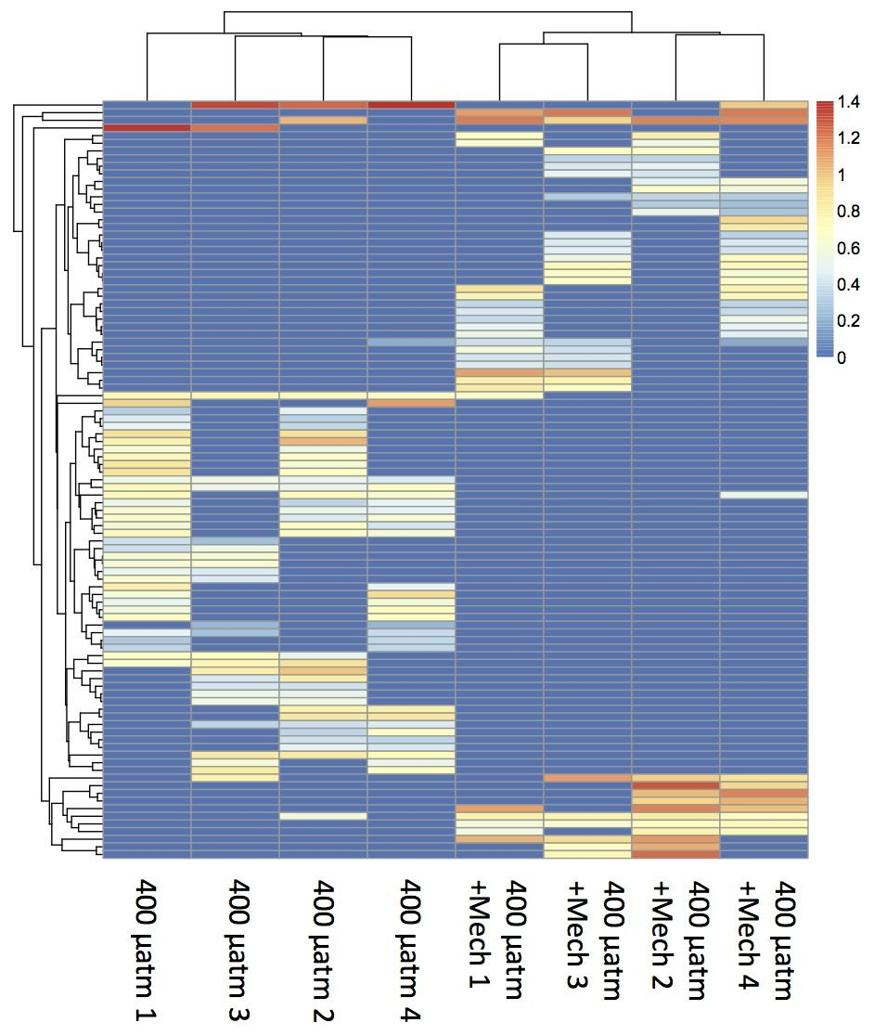

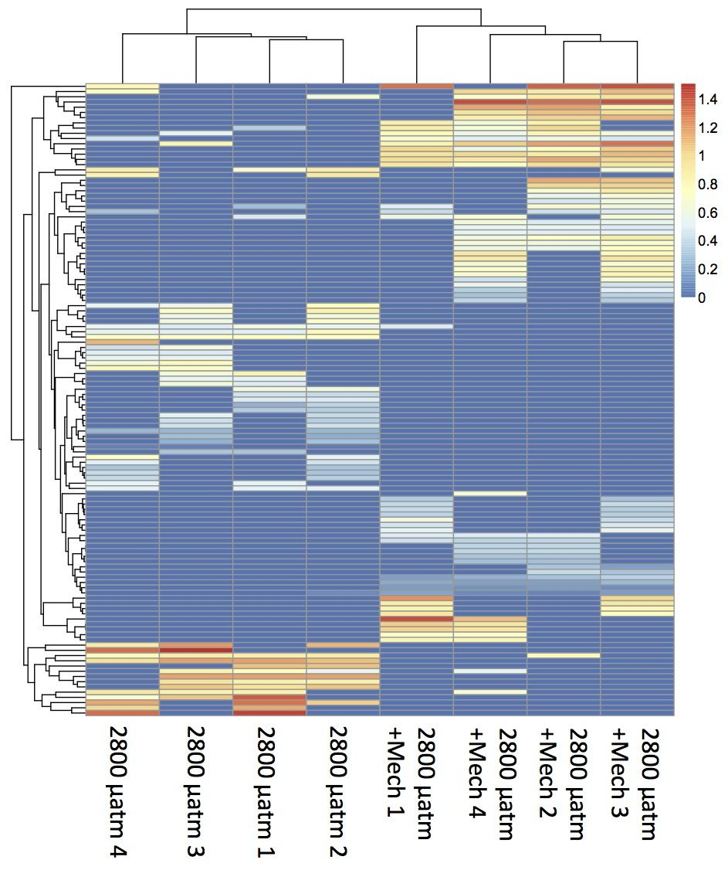
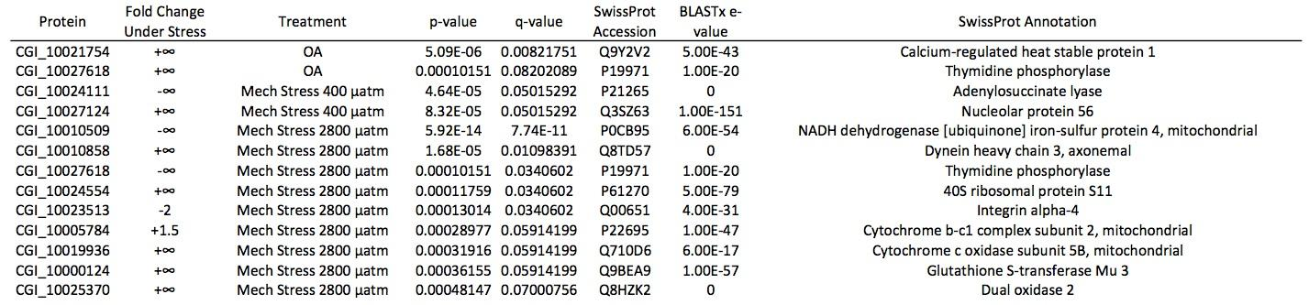

Table 5. Proteins differentially expressed in response to 2800 µatm compared to 400 µatm (“OA”), mechanical stress after one month at 400 µatm (“Mech Stress 400 µatm”), or mechanical stress after one month at 2800 µatm (“Mech Stress 2800 µatm”). A fold change of +infinity represents a protein that was not expressed at all in the control group whereas -infinity represents a protein not expressed at all in the stressed group.

The magnitude of the proteomic responses to the different stressors was similar (99-121 proteins showed at least a 5-fold change between treatment groups), but these proteomic responses differed in whether the proteins were general across the stress responses or responded to the stress in a more specific manner. Forty-five of the 120 proteins were unique to ocean acidification stress alone (all others were differentially expressed in response to mechanical stress as well) (Figure 4). The ocean acidification-specific proteins included v-type proton ATPase subunit C1 (regulation of intracellular H+), glutathione S-transferase omega-1 (detoxification and antioxidant response), and stress-induced phosphoprotein 1 (Supplementary Table S4). The responses to mechanical stress at different pCO2 had greater specificity and also differed from each other: 56 proteins were specific for mechanical stress response in 400 µatm-exposed oysters while 67 were specific to 2800 µatm oysters. Seven proteins were common to both mechanical stress responses, those that were annotated were prohormone-4, apolipophorin, kyphosocoliosis peptidase, 60S ribosomal protein L13, and SAM domain and HD domain-containing protein 1 (Supplementary Table S4). Eight proteins showed at least a 5-fold change in expression in response to all three stress conditions, including poly [ADP-ribose] polymerase, neurexin-4, small nuclear ribonucleoprotein, alpha-L-fucosidase, and cadherin-23 (Supplementary Table S4).

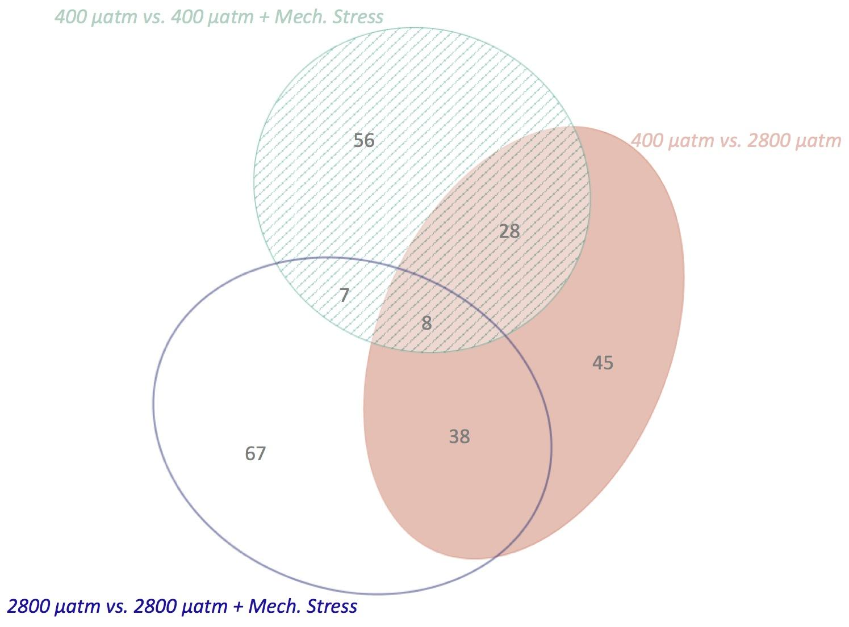
Figure 4. Venn diagram representing the proteins that showed at least a 5-fold change in expression between treatment groups and are expressed in at least two oysters. The proteins represented by the solid pink ellipse were those implicated in the response to 2800 µatm (control = 400 µatm), those in the open blue ellipse are different in response to mechanical stress in the 2800 µatm-exposed oysters, and those in the striped aqua ellipse changed in response to mechanical stress at 400 µatm. Gray numbers represent the number of proteins in each segment of the ellipses.

Eleven proteins involved in glycogenolysis and glycogenesis were identified in the sequenced proteins. These proteins are glycogen phosphorylase (CGI_10016530), glycogen debranching enzyme (CGI_10005875), glycogen synthase kinase-3 beta (CGI_10018859), glycogenin-1 (CGI_10023521), putative glycogen synthase (CGI_10017418), 1,4-alpha-glucan branching enzyme (CGI_10025236), phosphoglucomutase (CGI_10011818), lysosomal alpha-glucosidase (CGI_10009967), neutral alpha-glucosidase (CGI_10028648), and two hexokinases type 2 (CGI_10023886 and CGI_10017042). For almost all of these proteins, the directionalities of the protein expression in response to elevated pCO2 only and to mechanical stress after exposure to elevated pCO2 were in opposite directions (Table 6).
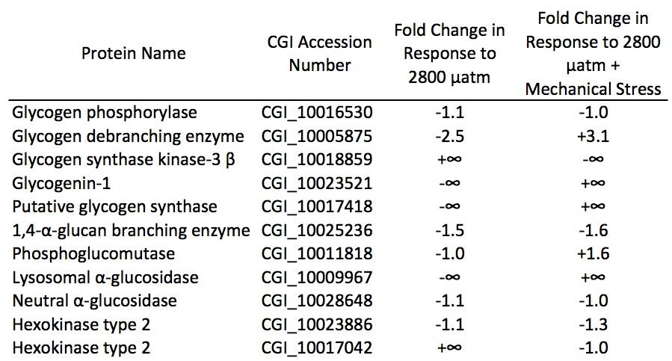
Table 6. Glycogen metabolism proteins identified from protein sequences. Fold change in response to 2800 µatm is calculated by dividing average expression of the protein across oysters at 2800 µatm by average at 400 µatm. Fold change in response to mechanical stress at 2800 µatm is the average expression in mechanically stressed oysters from the 2800 µatm treatment divided by the average expression at 2800 µatm.

Fatty Acids
There was no difference in fatty acid (FA) profiles among the three treatments (non-mechanically stressed oysters at 400, 1000, and 2800 µatm) (Figure 5). There is also no significant difference in total fatty acid per milligram tissue (data not shown). Twenty-one fatty acid peaks were identified in the 24 samples, which is within the range of 16-35 FAs found in other studies of bivalves (Soudant et al. 1999; Milke et al. 2004; Pettersen et al. 2010; Both et al. 2011). Among those fatty acids identified were 16:0; 18:0; 18:1n-9; 18:1n-7; 18:2n-6; ALA (18:3n-3); ARA (20:4n-6); EPA (20:5n-3); DPA (22:5n-6); n-3 DPA (22:5n-3); and DHA (22:6n-3). Raw and normalized fatty acid data are available in Supplementary Table S7 (File).
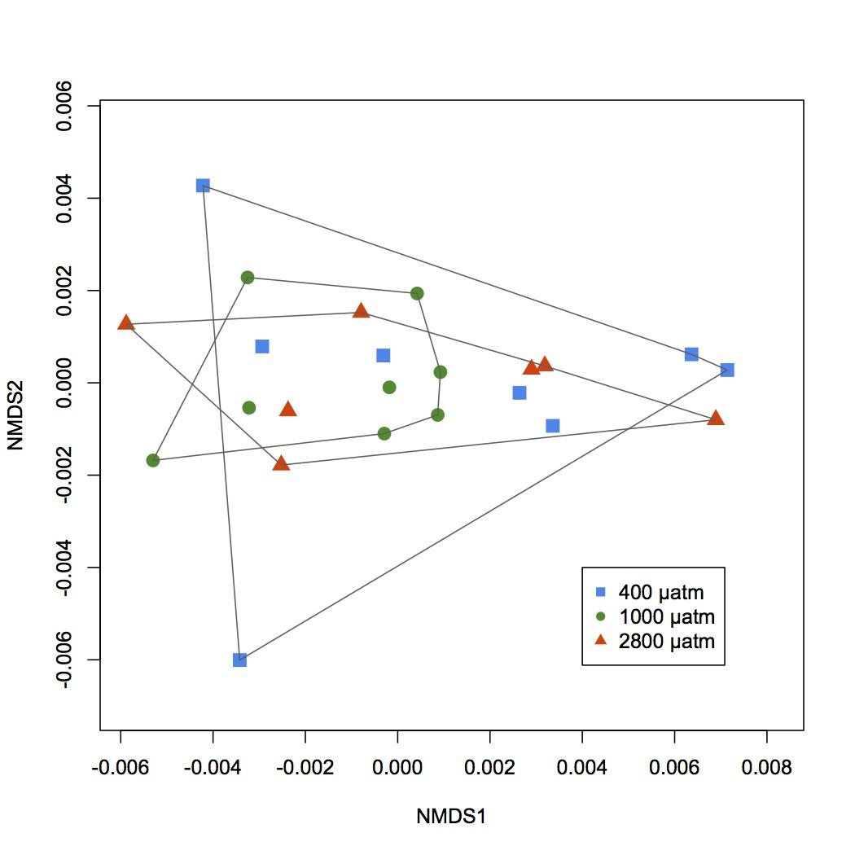
Figure 5. NMDS depicting fatty acid profiles for unstressed oysters from 400 (blue squares), 1000 (green circles) and 2800 (orange triangles) µatm. There are no differences in relative amounts of fatty acids among the three treatment groups.

Micromechanical Properties
Micromechanical properties were tested within the outer 3 mm of the growing edge (posterior) of left shell valves. Both Vickers microhardness and fracture toughness differed significantly among pCO₂ treatments (microhardness: Welch ANOVA, p = 0.014; fracture toughness: one-way ANOVA, p = 0.003)(Fig. 8). The microhardness of shells grown at 1000 µatm was significantly lower than that of shells grown at 400 µatm (Games-Howell: p < 0.05). Shells grown at 2800 µatm showed a trend toward lower microhardness as compared to the 400 µatm control group, but this comparison was not statistically significant (Games-Howell: p = 0.119). In contrast, fracture toughness was significantly lower in shells grown at 2800 µatm as compared to both the 400 and 1000 µatm treatments, but the 400 and 1000 µatm treatments did not differ (Tukey HSD: p < 0.05). Representative cracks formed by micromechanical testing are shown in Supplementary Information S1.

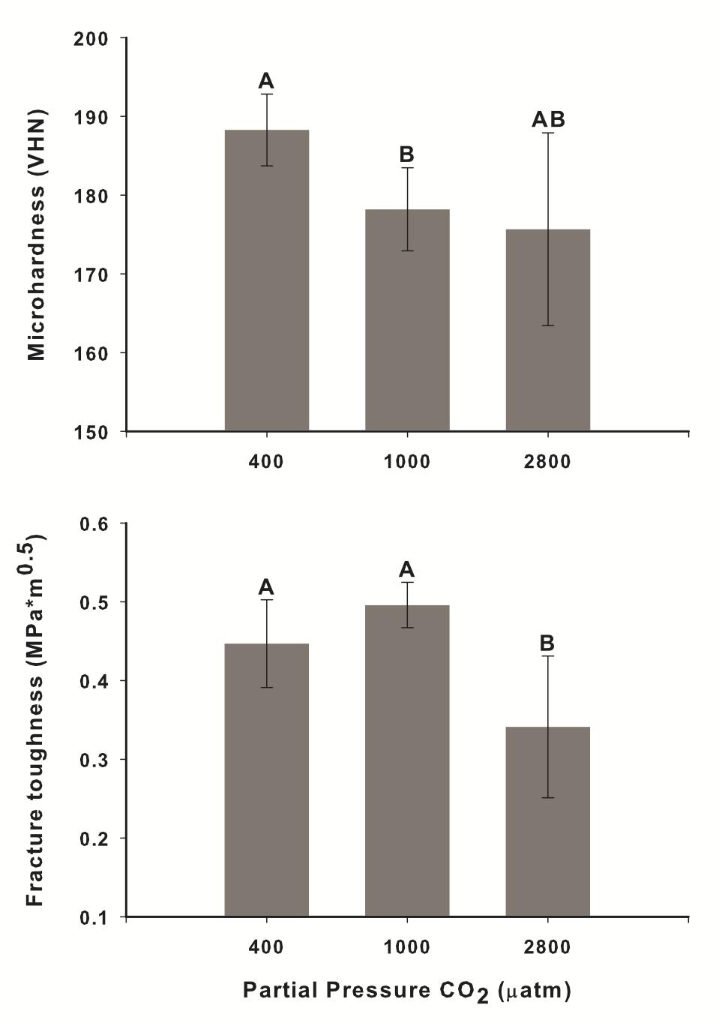

Fig. 6. Mean Vickers microhardness and fracture toughness of C. gigas shells (+/- 95% C.I.), tested within the outer 3 mm of the shell’s growing edge. Groups marked with different letters are significantly different (p < 0.05). n = 5-7 shells per treatment.
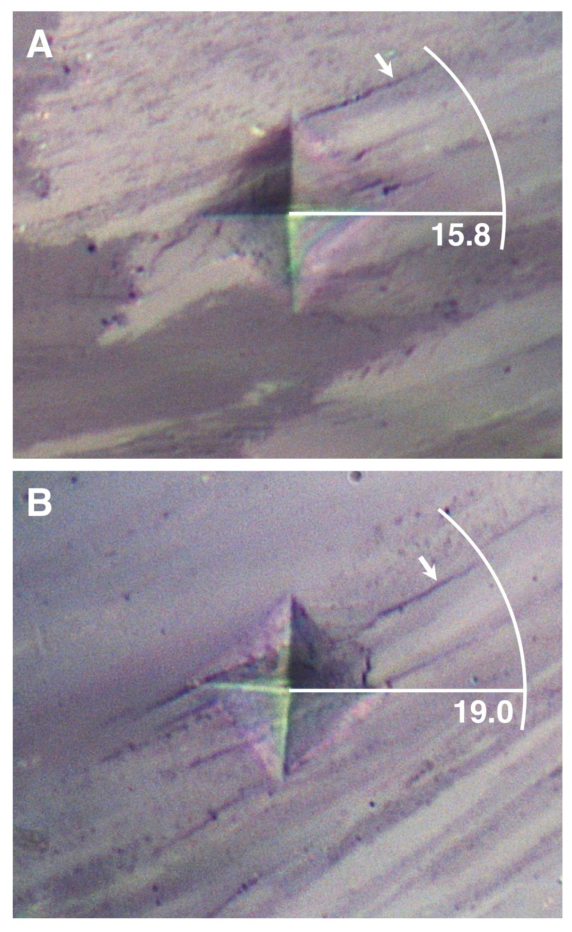

Supplementary Information S1. Representative indents made during micromechanical testing for the (A) 400 uatm and (B) 2800 uatm treatment. The radius of a circle radiating from the center of the indent enclosing all visible cracks was used to calculate fracture toughness, a portion of which is shown for each treatment. Arrow denotes the longest crack found for each indent. Radius length is shown on the image in um. Mean crack radius was similar between the 400 and 1000 uatm treatments.

---

DISCUSSION
Ocean acidification affects multiple, disparate physiological processes in C. gigas, but to different degrees, resulting from physiological trade-offs. Essential processes, such as lipid metabolism and mortality in response to heat shock, are not affected by a one month exposure to elevated pCO2, whereas processes less essential to daily function, such as the deposition and maintenance of new shell, appear to be impacted. This suggests that C. gigas is able to maintain a certain level of physiological function until it encounters another stress that disrupts homeostasis. The mechanisms behind some of these trade-offs are revealed through proteomics. C. gigas showed a high degree of plasticity in the proteomic response to elevated pCO2, but there was a cost in the form of shell micromechanical properties and the ability to launch a normal stress response.

Molecular physiological changes in response to ocean acidification
Ocean acidification significantly affected the underlying molecular physiology of C. gigas after one month of exposure. These effects are clearly demonstrated at the proteomic level. One hundred nineteen proteins in gill tissue contributed to a proteomic shift in ocean acidification-exposed oysters (2800 µatm pCO2), compared to those kept at ambient pCO2 (400 µatm). This group of proteins was enriched compared to the entire gill proteome for the biological processes of cell adhesion, transcription, and cell differentiation and morphogenesis.
Based on the proteomic response, the oysters’ cellular physiology was affected by the elevated pCO2. Proteins that were expressed higher by at least 5-fold after a one month exposure to elevated pCO2 compared to low pCO2 included UDP-N-acetylhexosamine pyrophosphorylase and N-acetylgalactosamine kinase (galactose metabolism); stress-induced-phosphoprotein 1 and T-complex protein 1 subunit eta (molecular chaperones); glutathione S-transferase omega-1 (detoxification); and cysteine-tRNA ligase, cytochrome c oxidase, and NADH dehydrogenase (cellular respiration and electron transport chain). The increased expression of the cellular respiration proteins and galactose metabolism could indicate increased metabolism in response to an ongoing stress (Mizock 1995). Increased metabolism leads to production of reactive oxygen species (ROS) (Mohanty et al. 2000). It is also possible that elevated cellular CO2 and H+ directly cause increased oxidative stress (Dean 2010; Tomanek et al. 2011). The expression of glutathione S-transferase (GST), a scavenger of ROS, increased concurrently. GST can protect cells against damage from ROS and may even inhibit resulting apoptosis (Sharma et al. 2004). Invertebrates frequently experience oxidative stress during ocean acidification exposure as evidenced at the molecular level (Todgham & Hofmann 2009; Tomanek et al. 2011). In a two-week exposure to elevated pCO2, C. virginica showed mostly up-regulation of oxidative stress and cytoskeletal proteins in mantle tissue (Tomanek et al. 2011). Increased expression of molecular chaperones is also a sign of cellular damage during stress (reviewed in Feder and Hofmann 1999).
A variety of important physiological processes were suppressed by the exposure to elevated pCO2. Proteins that were down-regulated in 2800 µatm-exposed oysters included serine-pyruvate aminotransferase (gluconeogenesis); poly [ADP-ribose] polymerase 3 (DNA repair); v-type proton ATPase (H+ transport); and lymphocyte cytosolic protein 2 (immune response). The down-regulation of a protein involved in gluconeogenesis and up-regulation of two involved in galactose metabolism (which also produces glucose) could be evidence of a trade-off in glucose production where one pathway is favored during stressful conditions. Changes in carbohydrate metabolism, especially increased metabolism and decreased storage, are a common stress response in a variety of taxa (Mizock 1995; Parrou et al. 1997). Decreased expression of proteins involved in DNA repair and the immune response may signal a re-allocation of resources that becomes necessary during prolonged environmental stress. Changes in metabolism, although mostly metabolic suppression, have been observed in oysters exposed to prolonged hypoxia (David et al. 2005) and ocean acidification (Lannig et al. 2010).
The invertebrate proteomic responses to ocean acidification have revealed that elevated pCO2 significantly alters both protein expression and posttranslational modifications (PTMs) of proteins. In adult C. virginica, 54 proteins were differentially regulated in response to OA with an overlap in the functional groups found to be important in this study (Tomanek et al. 2011). In C. gigas and C. hongkongensis larvae, ocean acidification prompted changes in expression of proteins involved in cellular structure and cytoskeleton, energy metabolism, and calcification, however, PTMs in the phosphoproteome of C. hongkongensis were greater than changes at the protein expression level (Dineshram et al. 2013; Dineshram et al. 2012). Similarly, changes in protein expression and PTMs were observed in larval barnacle response to ocean acidification (Wong et al. 2012). PTMs likely played a role in this study as well, but we chose to focus on the diversity of proteins and their expression differences, which would be lost if the focus was on PTMs. Changes in protein expression constitute many of the important molecular physiological changes that are occurring in response to ocean acidification, but further research into the additional role of PTMs could provide important insight.

Trade-offs in response to elevated pCO2
Environmental stress can frequently lead to changes in energy budget as an organism shifts resources to maintain homeostasis. Larval sea urchins allocate less energy towards somatic growth at elevated pCO2 compared to ambient (Stumpp et al. 2011a), but once corrected for developmental stage, expression of metabolically important genes differs little between pCO2 levels (Stumpp et al. 2011b). Adult C. gigas appear to be similarly affected by ocean acidification in that some physiological processes are altered compared to the control treatment (deposition and maintenance of new shell, response to a second stress), whereas others show no difference between pCO2 levels (fatty acid profiles, heat shock response). Energy allocation and metabolism were not measured directly in this study and there are likely many other processes that would complete the picture of physiological trade-offs, but the processes that we chose provide some insight into these potential trade-offs. Fatty acid profiles result from metabolism of lipids, which are an important source of energy for C. gigas. Growth of a structurally sound shell is a resource intensive process in molluscs and can represent an important energy output (Palmer 1992; Paine 1971). Lastly, response to environmental stress (using mechanical stress as a proxy) is necessary for survival in a dynamic environment, but may not be a response that is used on a daily basis.

Fatty acid profiles do not change in response to elevated pCO2
There was no difference in relative proportions of fatty acids (FAs) in C. gigas whole body tissue after one month of exposure to 1000 µatm or 2800 µatm pCO2. Oysters and other bivalves are highly dependent on FAs as a main energy source, especially poly-unsaturated fatty acids (PUFAs) (Milke et al. 2004; Soudant et al. 1999; Pettersen et al. 2010; Trider & Castell 1980). Changes in physiological state, such as those induced by reproduction or poor nutrient supply, can alter the relative proportions of FAs in oyster tissue (Both et al. 2011; Soudant et al. 1999). It is possible that an environmental stress can trigger a change in bivalve physiology and result in changes in fatty acid metabolism and/or storage. In the case of ocean acidification, C. gigas is able to maintain homeostasis of both total and relative amounts of important FAs. Lipid supply was also unaltered in larval sea urchins that were smaller at elevated pCO2 but maintained the same lipid and protein levels as control larvae (Matson et al. 2012). Exposure time and/or life stage may play an important role in the effects of ocean acidification on lipid levels. After 11 weeks of exposure to pCO2 of 800 µatm, juvenile C. virginica had significantly less lipid per gram body weight than control oysters (Dickinson et al. 2012). The extended stress of the 11 week exposure in Dickinson et al. (2012) may have overwhelmed C. virginica’s ability to maintain lipid homeostasis, suggesting that oyster energy metabolism may fail under consistent ocean acidification stress.

Lethal heat temperature does not change with pCO2
Response to acute heat shock was not affected by pCO2 level. We hypothesized that elevated pCO2 would lower the temperature threshold for mortality after heat exposure. The similar mortality profiles in response to heat shock across the three pCO2 treatments could be evidence that 1) pCO2 has a relatively small effect on the oyster heat shock response, 2) we measured a gross response to heat shock and there may have been a more nuanced, yet significant, effect at the cellular level, and/or 3) that 1°C is too big of a difference between heat shock temperatures and there may have been differential mortality at a fraction of a degree. The last is improbable since if it were true, we would expect a faster mortality rate in the elevated pCO2 oysters at exposure to 44°C. During more moderate but longer-term elevated temperature exposure, oysters are not impacted by the interactive effects of elevated temperature and pCO2 on their growth and survival (Talmage and Gobler 2011). There can be more nuanced effects, however, such as suppressed standard metabolic rate at high pCO2 and temperature (Lannig et al. 2010) and a slightly depressed oxidative stress response (Matoo et al. 2013).

Shell mechanical properties are affected by elevated pCO2
Shell microhardness and fracture toughness were both affected by exposure to elevated pCO2, but to a slightly different extent. Microhardness, a measure of a material’s resistance to deformation, tested at the shell’s growing edge was reduced at elevated pCO2 (1000 µatm) as compared to the control (400 µatm), whereas fracture toughness, a measure of the propensity for cracks to propagate within a material, was reduced only at 2800 µatm. Given that both measurements depend on the microstructural arrangement of the shell and the extent and distribution of elastic elements within the shell (i.e. the shell organic matrix) (Lee et al. 2008), exposure to elevated pCO2 may lead to dose-dependent differences in the structure and/or composition of newly formed shell. Such changes could result either from alterations in the physiology of shell deposition or the ability to prevent dissolution under varying seawater hydrochemistry. It is noteworthy that diminished microhardness was observed at 1000 µatm, despite the fact that the 2800 µatm exposure was the only treatment undersaturated with respect to calcite.
Across multiple bivalve species, ocean acidification has been shown to affect shell growth, structure, and mechanical properties. Even at pCO2 of 1665 µatm and calcite saturation state of 1.64 (supersaturated) juvenile C. virginica shells grew more slowly compared to control oysters (Talmage & Gobler 2011). Elevated pCO2 causes decreased shell growth (Michaelidis et al. 2005; Talmage & Gobler 2011; Melzner et al. 2011; Gazeau et al. 2007), greater shell dissolution (Lannig et al. 2010; Melzner et al. 2011; Dickinson et al. 2013), and changes to shell microstructure (Beniash et al. 2010; Dickinson et al. 2013; Welladsen et al. 2010) in bivalves. Many of these results were measured at saturation state of calcite greater than 1, which is still thermodynamically favorable for shell deposition and maintenance. Similar effects were observed in the current study, where micromechanical properties were negatively impacted at both 2800 µatm (omega = 0.5) and at 1000 µatm (omega = 1.3). Even above the saturation threshold, as omega decreases the driving force towards mineralization is reduced. Since calcification is an energetically intensive process (Paine 1971; Palmer 1992; Rosenberg & Hughes 1991), one explanation for significant effects on CaCO3 structures at omega > 1 is that energetic resources are being reallocated to other, non-calcification physiological processes in order to maintain homeostasis.

Response to stress is altered by elevated pCO2
Even if C. gigas is able to acclimatize to elevated pCO2 over one month, the altered physiological state prompted by this environmental change affected a normal response to mechanical stress. At 400 µatm, proteins involved in C. gigas’s proteomic response to mechanical stress were enriched in biological processes related to cellular transport. The two proteins that were significantly differentially expressed were adenylosuccinate lyase (AMP synthesis, down-regulated after mechanical stress) and nucleolar protein 56 (ribosomal biogenesis, up-regulated after mechanical stress). A larger variety of biological processes were enriched in the response to mechanical stress in the 2800 µatm-exposed oysters, suggesting that more pathways were disrupted by the combined stressors. These included proteins involved in neuromuscular process, cell junction assembly, cell and tissue morphogenesis, and carbohydrate metabolism. The enrichment of proteins (mostly expressed higher after mechanical stress) belonging to polysaccharide and monosaccharide metabolism may indicate mobilization of energy reserves under stress, a response that was not as important after mechanical stress in control oysters. More proteins were significantly differentially expressed in response to the two stressors of 2800 µatm pCO2 and mechanical stress than to either of those stresses on their own, evidence of a synergistic response at the proteomic level. Proteins that were significantly differentially expressed after response to mechanical stress in the elevated pCO2 oysters were involved in cellular respiration and electron transport (NADH dehyrogenase, cytochrome c, and cytochrome b), cytoskeleton structure (dynein), cell growth (thymidine phosphorylase), translation (40S ribosomal protein), receptor binding (integrin), and detoxification (glutathione S-transferase and dual oxidase).
The proteomic response to mechanical stress after one month at 2800 µatm was both qualitatively and quantitatively different from the response to mechanical stress in control oysters. Only 15 of the proteins with at least a 5-fold expression difference changed in response to mechanical stress in both pCO2 treatment groups. These proteins represent a small portion of the proteomic response to mechanical stress - 15.1% and 12.4% of the responses at 400 and 2800 µatm, respectively - underlining the altered stress response at 2800 compared to 400 µatm. The expression levels of seven of these proteins were affected by mechanical stress at both pCO2 but not by ocean acidification, five of which were expressed less after mechanical stress (CGI_1004918, CGI_10027073, SAM domain and HD domain-containing protein 1, kyphoscoliosis peptidase, and prohormone-4) and two of which were expressed higher after mechanical stress (apolipophorin and 60S ribosomal protein L13). These seven proteins likely represent an integral part of the cellular response to mechanical stress since the direction of their fold change was conserved at both pCO2.
Mechanical stress disrupted the proteomic response to ocean acidification, reversing the expression trends of proteins. Many of these proteins are involved in carbohydrate metabolism, reflecting changes in energy demand under different stresses. Of the eleven proteins that were identified in the glycogenolysis/glycogenesis pathway, six of them showed a change in direction of expression in response to the dual stress of elevated pCO2 and mechanical stress versus the single stress of ocean acidification. In oysters exposed only to elevated pCO2, there was a trend towards increased anabolism of carbohydrates (increased expression of succinyl-CoA ligase subunit B, mitochondrial) and decreased fucose metabolism (decreased expression of alpha-L fucosidase), but once exposed to mechanical stress these oysters decreased expression of 6-phosphogluconolactonase, a protein involved in carbohydrate anabolism, and increased expression of alpha-L fucosidase. Serine-pyruvate aminotransferase, which is involved in the tricarboxylic citric acid cycle, has lower expression at 2800 µatm compared to 400 µatm but then expression increased in the high pCO2 oysters upon exposure to mechanical stress. Previously, Lannig et al. (2010) found that long-term exposure to ocean acidification resulted in metabolite changes likely indicating metabolic shifts. Similarly, larval urchins had decreased expression of metabolism-related genes after ocean acidification exposure (Todgham and Hofmann 2009). Mechanical stress appears to reverse the physiological response of metabolism depression that occurs upon exposure to ocean acidification, which may have detrimental effects on a sustained stress response.
Mechanical stress also affected apoptotic pathways in C. gigas, but in different ways in oysters from the two different pCO2 treatments. Mechanical stress of 400 µatm oysters instigated increased expression of the protein CDGSH iron-sulfur domain-containing protein 2, which suppresses autophagy, an end step of apoptosis. After mechanical stress in the 2800 µatm oysters, the expression of caspase-7 (a mediator of apoptosis) decreased, another sign of apoptosis depression. Concurrently, however, there was an increase in expression of engulfment cell motility protein 2, which is responsible for disposal of apoptotic cells. Cell growth/proliferation proteins also changed in response to stress. Expression of proteins responsible for cell growth (thymidine phosphorylase and tyrosine protein kinase yes) was increased after a one month exposure to ocean acidification while these same proteins were down-regulated after mechanical stress at elevated pCO2. These pieces of evidence all suggest that there is increased apoptosis and decreased cell growth during the dual stress of elevated pCO2 and mechanical stress. C. gigas has a well developed apoptosis system and expression of genes in the apoptotic pathway increases in hemocytes exposed to disease stress (Zhang, Li, Zhang 2012; Timmins-Schiffman & Roberts 2012). Differential expression of genes involved in apoptosis was also seen in both urchin larvae (Todgham & Hofmann 2009) and adult coral exposed to ocean acidification (Kaniewska et al. 2012).

Conclusion
Even though ocean acidification is frequently portrayed as detrimental to marine calcifiers, its effects on invertebrates range well beyond changes to the calcification process. The proteomic data presented in this study, as well as similar results in other studies (e.g. Tomanek et al. 2011; Todgham & Hofmann 2009; Wong et al. 2011), portray a complex physiological response to ocean acidification. In accordance with findings in other invertebrates, the C. gigas response to ocean acidification can be simplified as a shift in resource allocation in a stressful environment. Both proteomic plasticity and lipid metabolism were prioritized and are essential for continued survival under any conditions. The processes that were altered by ocean acidification - shell integrity and proteomic response to a second stress - are those that may not pose a fitness risk on a daily basis. Shell integrity and response to a second stress do become important in a dynamic environment or when there are multiple predators and in this way ocean acidification may decrease C. gigas fitness under chronic exposure. As low pH events become more frequent in C. gigas’s habitat, populations will need to adapt over short timescales to survive in a high pCO2 ocean. Recent evidence has shown that ocean acidification elicits an evolutionary response within one cohort of larvae in urchins, which have a similar life history strategy to C. gigas (Pespeni et al. 2013; Kelly et al. in press). It may be that the inherent genetic diversity that occurs in broadcast spawning invertebrates will provide the key to adaptation to the changing global climate.

SUPPLEMENTAL DATA
Supplementary Information S1: Representative indents made during micromechanical testing.

Supplementary Information S2: Workflow and queries for analyzing proteomics data in SQLshare.

Supplementary Table S3: ProteinProphet output for each technical replicate. Information for each protein includes percent coverage by sequenced peptides, total number unique peptides, total independent spectra (spectral count), and peptide sequences.

Supplementary Table S4: Protein expression values (NSAF) for each oyster for the 1,616 proteins identified. Also included are average expression values across treatments (i.e. 2800 avg NSAF is the average expression across all four high pCO2-exposed oysters); fold change for treatment/control oysters (i.e. Fold Diff OA is [2800 avg NSAF]/[400 avg NSAF]); columns for each of the three treatment comparisons with an asterisk indicating if the protein is >5-fold up- or down-regulated; SwissProt annotation, e-value, and gene description; proteins responsible for enrichment and the treatment comparisons in which they are enriched; a column indicating in which stress treatment proteins are differentially expressed (q-value > 0.1).

Supplementary Table S5: C. gigas proteins with associated SwissProt/UniProt-KB, Gene Ontology (GO), and GO Slim annotations.

Supplementary Table S6: Enriched biological processes for proteins >5-fold differentially expressed in the stress responses to elevated pCO2 of 2800 µatm (“OA”), mechanical stress after a one month exposure to 400 µatm (“Mech Stress 400 µatm”), and mechanical stress after a one month exposure to 2800 µtam (“Mech Stress 2800 µatm”). Table includes enriched GO term, number of proteins contributing to that GO term, p-value indicating degree of enrichment, the SwissProt accession numbers for those proteins, the fold enrichment for each GO term, and the false discovery rate (FDR).

Supplementary Table S7: Raw and normalized (proportion) fatty acid data for 8 oysters each from 3 treatments: 400, 1000, and 2800 µatm.

REFERENCES

ACKNOWLEDGEMENTS

